**School of Engineering**

**Dept. of CSE-AI&ML**

**Vacational Task for Sankranti and Pongal Holidays**

**Sub: Reinforcement Learning B.Tech-CSE(AI&ML) (All Sections)**

**Name : P Manik Tanay Reddy**

**Roll No : 2211CS020308**

**Section : AIML ZETA**

1. **Implement Upper-Confience bound algorithm (UCB) in Multi Arm Banding Problem to optimize player rewards in a basic game simulation with Python Program. The game scenario involves a player choosing between different "actions" (like doors, treasures, or paths), each with a hidden reward probability. The UCB algorithm must help the game adapt dynamically to maximize the player's experience.**

**1A. Code:**

import numpy as np

import matplotlib.pyplot as plt

import time

# Define the Game Environment

class GameEnvironment:

def __init__(self, actions: int):

"""

Initialize the game environment with hidden reward probabilities.

Parameters:

actions (int): Number of possible actions (e.g., doors, treasures, paths).

"""

self.actions = actions

self.hidden_rewards = np.random.uniform(0, 1, actions) # Hidden reward probabilities

def perform_action(self, action: int) -> int:

"""

Simulate performing an action and receiving a reward.

Parameters:

action (int): Index of the chosen action.

Returns:

int: Reward obtained (1 for success, 0 for failure).

"""

return 1 if np.random.rand() < self.hidden_rewards[action] else 0

# Define the UCB Agent

class UCBAgent:

def __init__(self, actions: int, exploration_param: float):

"""

Initialize the UCB agent.

Parameters:

actions (int): Number of possible actions.

exploration_param (float): Exploration parameter for UCB.

"""

self.actions = actions

self.exploration_param = exploration_param

self.action_counts = np.zeros(actions) # Number of times each action is chosen

self.action_rewards = np.zeros(actions) # Total rewards for each action

def select_action(self, current_step: int) -> int:

"""

Select an action based on the UCB formula.

Parameters:

current_step (int): Current step in the game.

Returns:

int: Index of the selected action.

"""

if current_step < self.actions:

return current_step # Ensure each action is tried at least once

ucb_values = self.action_rewards / (self.action_counts + 1e-5) + \

self.exploration_param * np.sqrt(np.log(current_step + 1) / (self.action_counts + 1e-5))

return np.argmax(ucb_values)

def update(self, action: int, reward: int):

"""

Update the agent's knowledge based on the reward received.

Parameters:

action (int): Index of the chosen action.

reward (int): Reward obtained from the chosen action.

"""

self.action_counts[action] += 1

self.action_rewards[action] += (reward - self.action_rewards[action]) / self.action_counts[action]

# Interactive Game Function

def play_game():

print("Welcome to the Treasure Hunt Game!")

print("There are hidden treasures behind different doors.")

print("Your goal is to maximize rewards by choosing the best door.")

print("The UCB Agent will guide you to make the best choices!")

num_actions = int(input("Enter the number of doors (e.g., 3, 5, 10): "))

steps = int(input("Enter the number of game rounds (e.g., 10,20, 50, 100): "))

exploration_factor = float(input("Enter the exploration factor for UCB (e.g., 1.0, 2.0): "))

# Initialize the game environment and agent

environment = GameEnvironment(num_actions)

agent = UCBAgent(num_actions, exploration_factor)

player_rewards = []

for step in range(steps):

print("\nRound", step + 1)

print("Choose a door (0 to", num_actions - 1, "):")

try:

player_choice = int(input("Your choice: "))

if player_choice < 0 or player_choice >= num_actions:

raise ValueError("Invalid door number.")

except ValueError as e:

print("Invalid input. The agent will choose for you!")

player_choice = agent.select_action(step)

reward = environment.perform_action(player_choice)

agent.update(player_choice, reward)

player_rewards.append(reward)

print(f"You chose door {player_choice}. Reward: {'💎' if reward else '❌'}")

print(f"Current Rewards: {sum(player_rewards)}")

time.sleep(1)

# Display the results

print("\nGame Over! Here are the results:")

print("Hidden Reward Probabilities:", environment.hidden_rewards)

print("Total Rewards Collected:", sum(player_rewards))

print("Action Counts:", agent.action_counts)

# Plot the performance

avg_rewards = np.cumsum(player_rewards) / (np.arange(1, steps + 1))

plt.figure(figsize=(12, 6))

plt.plot(avg_rewards, label="Average Reward")

plt.axhline(y=max(environment.hidden_rewards), color="r", linestyle="--", label="Optimal Reward")

plt.xlabel("Rounds")

plt.ylabel("Average Reward")

plt.title("Player Performance in the Game")

plt.legend()

plt.show()

# Run the Game

if __name__ == "__main__":

play_game()

**Output:**

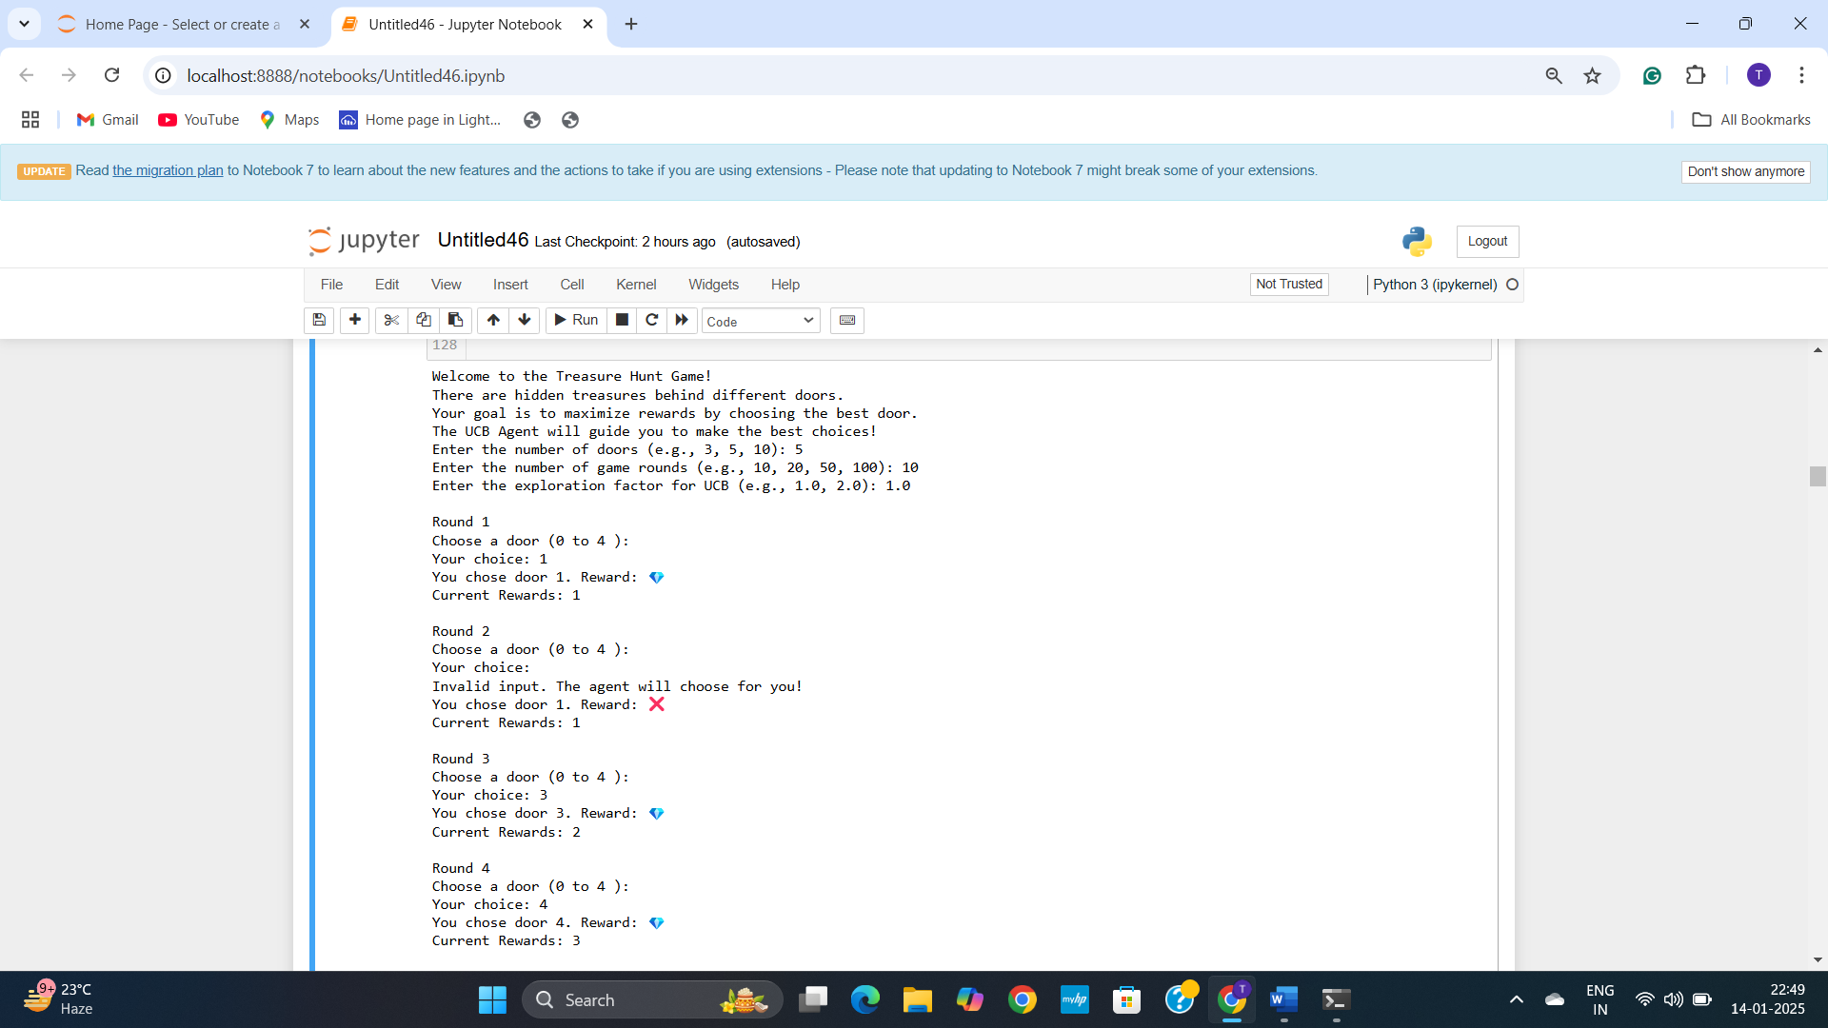

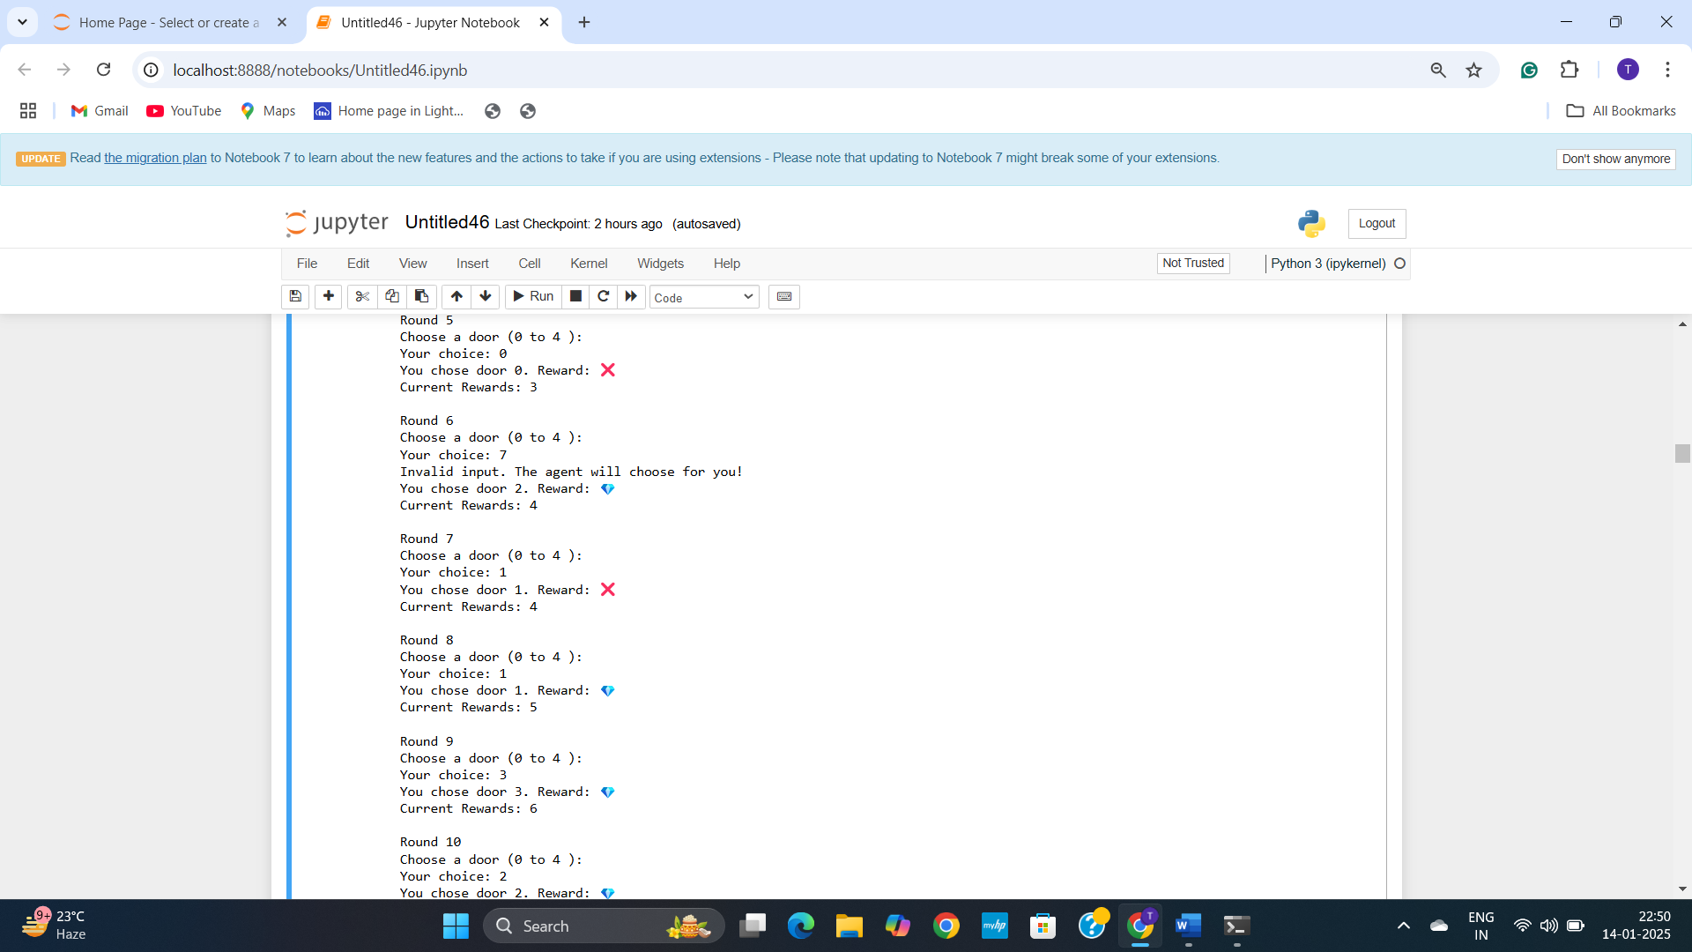

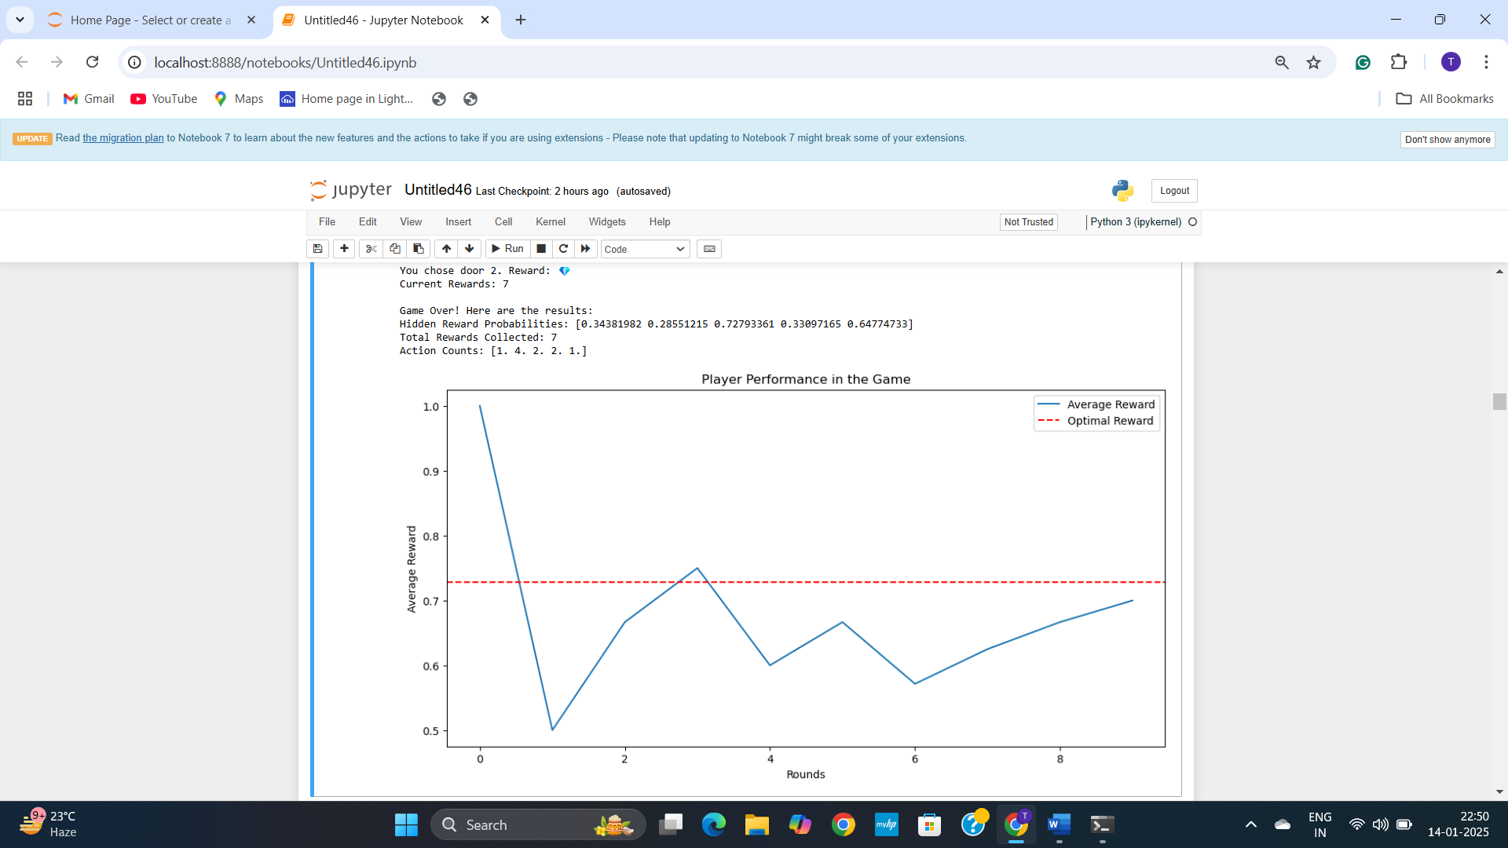

**Explanation:**

**UCB-Based Multi-Armed Bandit Game Simulation**

This Python program implements a game simulation based on the Multi-Armed Bandit problem using the Upper-Confidence Bound (UCB) algorithm. The simulation involves a player interacting with a game environment where they choose between multiple "actions" (e.g., doors, treasures, or paths). Each action has a hidden reward probability, and the UCB algorithm guides the player to maximize rewards over multiple rounds.

**Key Conditions in the Program**

1. **UCB Algorithm Implementation**:
   * The game explicitly requires using the UCB algorithm to optimize rewards.
   * The provided code uses the UCB formula:

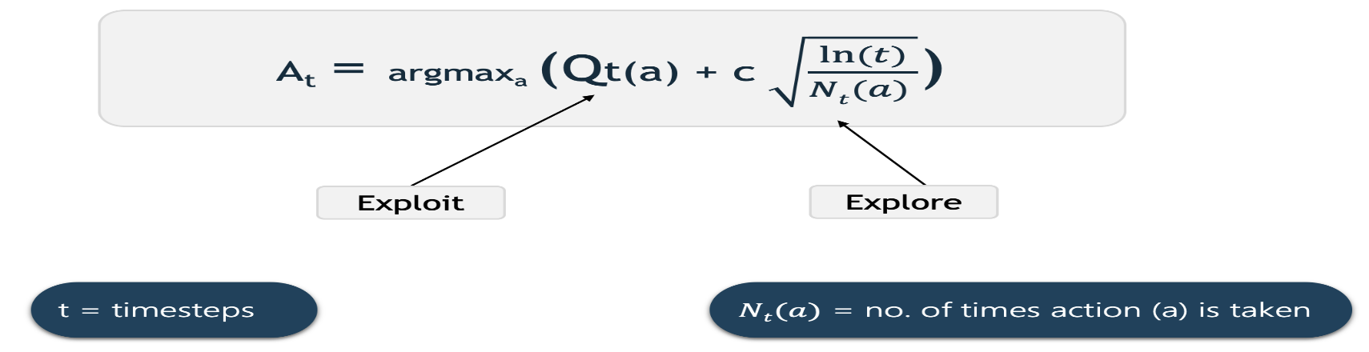

* + where Qt(a) is the average reward for action a, c is the exploration parameter, t is the current time step, and Nt(a) is the number of times action a was chosen.

1. **Multi-Armed Bandit Problem**:
   * The game scenario aligns perfectly with the **Multi-Armed Bandit Problem**:
     + Multiple "arms" (actions like doors, treasures, or paths).
     + Each action has a hidden reward probability.
     + The player (or agent) needs to explore and exploit to maximize total rewards.
2. **Dynamic Adaptation**:
   * The UCB algorithm dynamically balances **exploration** (trying less-frequented actions) and **exploitation** (choosing actions with higher expected rewards).
   * The code demonstrates this balance by updating rewards and action counts after each step.
3. **Player Rewards Optimization**:
   * The goal of the game is to maximize player rewards over multiple rounds, which is the core objective of applying the UCB algorithm.
   * The game tracks cumulative rewards and average rewards, providing clear metrics for success.
4. **Basic Game Simulation**:
   * The scenario is straightforward and focuses on player interaction with simple game mechanics (choosing actions, receiving rewards).
   * The implementation is user-friendly, with clear feedback and visualization of results.
5. **Adaptability**:
   * The UCB implementation allows the game to adapt dynamically based on the player’s actions and reward feedback.
   * The player’s choices influence the algorithm’s future decisions, improving the experience.

**How the Game Works:**

1. **Game Environment:**:
   * The game environment generates random reward probabilities for each "door."
   * The player interacts with the game by choosing a door in each round.
2. **Player Interaction**:
   * Players are prompted to choose a door during each round.
   * If the player enters an invalid input, the UCB agent will make the choice for them.
3. **Reward Feedback**:
   * Rewards are binary: 💎 (success) or ❌ (failure).
   * The total reward and the player’s choices are updated dynamically.
4. **Results**:
   * After all rounds, the game displays the hidden reward probabilities, total rewards collected, and the number of times each door was selected.
   * A graph shows the player’s average rewards compared to the optimal reward.

**Example:**

1. **Input**:
   * Number of doors: 5
   * Number of rounds: 20
   * Exploration factor: 1.5
2. **Output**:
   * Interactive gameplay showing rewards for each round.
   * A final plot displaying the player's average reward versus the optimal reward.

**Purpose:**

The program demonstrates how the UCB algorithm can optimize rewards in a Multi-Armed Bandit problem. It highlights how the algorithm balances exploration and exploitation, dynamically adapting to maximize performance.This implementation closely aligns with the requirement to optimize player rewards using the UCB algorithm in a game simulation with actions that have hidden reward probabilities.

1. **Imagine an IoT-based smart home system that dynamically optimizes energy üsage across multiple devices (e.g., air conditioner, heater, and lights). Each device has a varying energy consumption efficiency based on real-time environmental factors like temperature or occupancy. Design an UCB algorithm is used to determine which device settings (e.g., energy modes) should be prioritized to maximize energy efficiency and implement the algorithm in Python**

**2A. Code:**

import numpy as np

import matplotlib.pyplot as plt

class SmartHomeEnvironment:

def __init__(self, devices, modes_per_device):

self.devices = devices

self.modes_per_device = modes_per_device

self.efficiency_profiles = {

device: np.random.rand(modes) for device, modes in modes_per_device.items()

}

def get_reward(self, device, mode, temperature, occupancy):

base_efficiency = self.efficiency_profiles[device][mode]

adjustment = -abs(temperature - 22) * 0.01 + occupancy * 0.02

noise = np.random.normal(0, 0.05)

return max(0, base_efficiency + adjustment + noise)

class UCBOptimizer:

def __init__(self, devices, modes_per_device, exploration_param):

self.devices = devices

self.modes_per_device = modes_per_device

self.exploration_param = exploration_param

self.Q_values = {device: np.zeros(modes) for device, modes in modes_per_device.items()}

self.action_counts = {device: np.zeros(modes) for device, modes in modes_per_device.items()}

self.total_steps = 0

def select_mode(self, device):

modes = self.modes_per_device[device]

for mode in range(modes):

if self.action_counts[device][mode] == 0:

return mode

total_counts = np.sum(self.action_counts[device])

ucb_values = self.Q_values[device] + self.exploration_param * np.sqrt(

np.log(total_counts + 1) / (self.action_counts[device] + 1e-5)

)

return np.argmax(ucb_values)

def update(self, device, mode, reward):

self.action_counts[device][mode] += 1

self.Q_values[device][mode] += (reward - self.Q_values[device][mode]) / self.action_counts[device][mode]

def optimize(self, environment, steps, temperature_series, occupancy_series):

rewards = {device: [] for device in self.devices}

for step in range(steps):

temperature = temperature_series[step]

occupancy = occupancy_series[step]

for device in self.devices:

mode = self.select_mode(device)

reward = environment.get_reward(device, mode, temperature, occupancy)

self.update(device, mode, reward)

rewards[device].append(reward)

return rewards

def add_device(devices, modes_per_device):

new_device = input("Enter the name of the new device: ")

new_modes = int(input(f"Enter the number of modes for {new_device}: "))

devices.append(new_device)

modes_per_device[new_device] = new_modes

print(f"{new_device} added with {new_modes} modes.")

return devices, modes_per_device

# Main Simulation

if __name__ == "__main__":

# Configuration

devices = ["Air Conditioner", "Heater", "Lights"]

modes_per_device = {"Air Conditioner": 3, "Heater": 3, "Lights": 2}

# Ask user if they want to add a new device

add_device_choice = input("Do you want to add a new device? (yes/no): ").lower()

if add_device_choice == "yes":

devices, modes_per_device = add_device(devices, modes_per_device)

steps = 1000

exploration_param = 2.0

# Simulate environmental conditions

temperature_series = np.random.randint(18, 30, steps)

occupancy_series = np.random.randint(0, 5, steps)

# Initialize environment and optimizer

environment = SmartHomeEnvironment(devices, modes_per_device)

optimizer = UCBOptimizer(devices, modes_per_device, exploration_param)

# Run optimization

rewards = optimizer.optimize(environment, steps, temperature_series, occupancy_series)

# Plot results

plt.figure(figsize=(12, 6))

for device in devices:

avg_rewards = np.cumsum(rewards[device]) / np.arange(1, steps + 1)

plt.plot(avg_rewards, label=f"{device} - Avg Efficiency")

plt.title("Energy Efficiency Optimization using UCB")

plt.xlabel("Steps")

plt.ylabel("Average Efficiency")

plt.legend()

plt.show()

# Calculate final average efficiencies

final_averages = {device: np.mean(rewards[device]) for device in devices}

# Sort devices by efficiency

prioritization_order = sorted(final_averages.items(), key=lambda x: x[1], reverse=True)

# Print prioritization

print("\nPrioritization Order (Device - Efficiency):")

for device, efficiency in prioritization_order:

print(f"{device} - {efficiency:.2f}")

**Output:**

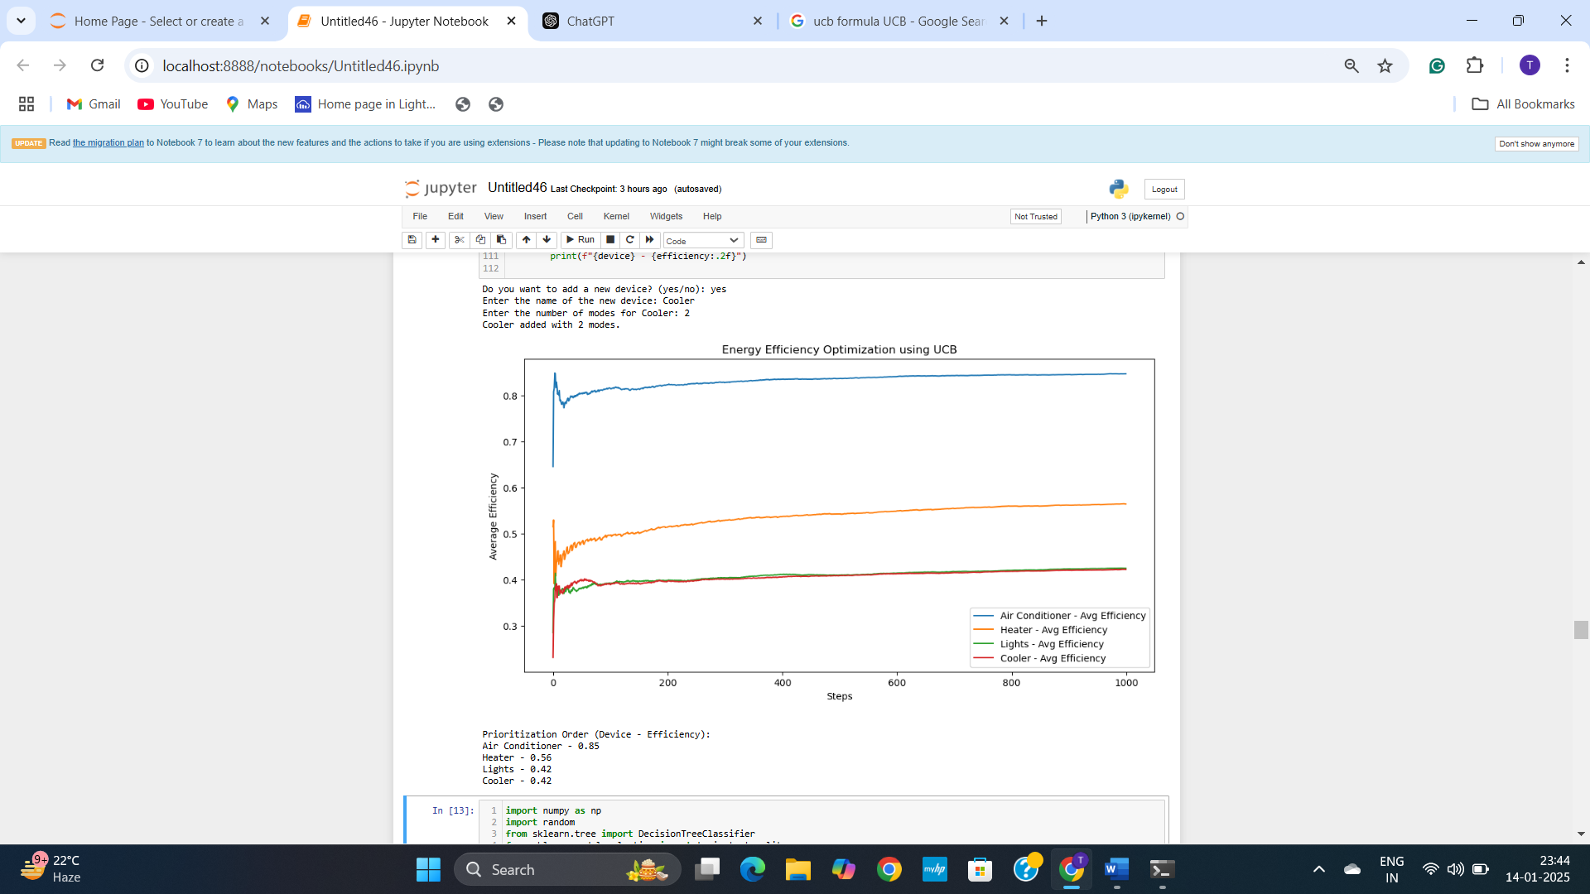

**Explanation:**

**Project Overview**

This project simulates a smart home environment with various devices, optimizing their energy efficiency using the Upper Confidence Bound (UCB) algorithm. The UCB algorithm dynamically selects the optimal modes of devices by balancing exploration (trying less-used modes) and exploitation (choosing the best-known modes).

**Key Components**

1. **Smart Home Environment (Smart Home Environment Class):**
   * Simulates smart home devices and their energy efficiency profiles.
   * Calculates a reward (efficiency) for operating a device in a specific mode, considering environmental factors like temperature and occupancy.
   * Efficiency profiles are initialized randomly for each device and mode.
2. **UCB Optimizer (UCB Optimizer Class):**
   * Implements the UCB algorithm to optimize device modes.
   * Tracks the average reward (efficiency) and action counts for each mode of a device.
   * Selects modes based on UCB values, which factor in past performance and exploration potential.
3. **User Interaction:**
   * Users can add new devices and specify their modes interactively.
   * Devices and modes are dynamically updated in the environment and optimization process.
4. **Simulation:**
   * Runs the optimization over a defined number of steps.
   * Simulates environmental conditions (temperature and occupancy) over time.
   * Plots the average efficiency of each device over the simulation period.
5. **Output:**
   * Visualizes the optimization results via a plot of average efficiencies.
   * Displays a final prioritization order of devices based on their average efficiencies.

**How It Works**

1. **Initialization:**
   * The Smart Home Environment initializes devices and their efficiency profiles.
   * The UCB Optimizer initializes tracking variables for rewards and action counts.
2. **Simulation:**
   * Environmental factors (temperature and occupancy) are simulated as random series.
   * For each step, the optimizer:
     + Selects a mode for each device using the UCB algorithm.
     + Queries the environment for the reward of the chosen mode.
     + Updates the mode's reward estimate using the observed reward.
3. **User Interaction:**
   * Users can add new devices and specify the number of modes via console input.
4. **Visualization and Results:**
   * A plot of cumulative average rewards for each device is generated.
   * Devices are prioritized based on their average efficiency.

**Code Details**

1. **Smart Home Environment Class**
   * **Attributes:**
     + devices: List of device names.
     + modes_per_device: Dictionary mapping devices to their number of modes.
     + efficiency_profiles: Randomly generated efficiency values for each mode.
   * **Methods:**
     + get_reward(device, mode, temperature, occupancy): Computes the efficiency reward for a given device mode based on environmental factors.
2. **UCB Optimizer Class**
   * **Attributes:**
     + Q_values: Tracks average rewards for each mode of each device.
     + action_counts: Tracks how many times each mode has been selected.
     + exploration_param: Controls the balance between exploration and exploitation.
   * **Methods:**
     + select_mode(device): Selects the optimal mode for a device using the UCB formula.
     + update(device, mode, reward): Updates reward estimates for a mode.
     + optimize(environment, steps, temperature_series, occupancy_series): Runs the optimization process.
3. **Main Simulation**
   * Configures the environment and optimizer.
   * Runs the optimization process.
   * Visualizes results and calculates final prioritization.

**How to Run the Code**

1. Install required libraries:

pip install numpy matplotlib

1. Run the script:

python smart_home_ucb.py

1. Interact with the program:
   * Add new devices when prompted.
   * Observe the optimization results via the generated plot and console output.

**Key Functions and Formula**

1. **UCB Formula:**
   * Q: Average reward for a mode.
   * C: Exploration parameter.
   * T: Total number of steps (sum of actions taken for all modes).
   * N: Number of times the mode has been selected.
2. **Reward Calculation:**

**Sample Results**

* **Plot:** The generated plot shows the average efficiency over time for each device.
* **Prioritization:** Devices are ranked by their final average efficiency, aiding in energy management decisions.

**Applications**

* Energy-efficient smart home management.
* Dynamic optimization in IoT systems.
* Balancing resource allocation in multi-device environments.

1. **Develop a Chess-like game using PAC(Probably approximately correct) algorithm where the Problem set-up is as follows:**

**Problem Setup**

**i) Game Environment: Simplify chess to a smaller grid with basic pieces (like pawns and a king).**

**ii) PAC Learning: Train a model to approximate a move policy that is "probably approximately correct" (i.e., likely correct within some error bounds).**

**Implementation Goals: Use supervised learning to train a model with a dataset of board states and corresponding optimal moves.**

**Implementation:**

**1. The chess-like game will have a simplified 4x4 board with only a king and a few pawns.**

**2. PAC learning will train a simple classifier (e.g., decision tree) to predict moves.**

**3A. Code:**

import numpy as np

import random

from sklearn.tree import DecisionTreeClassifier

from sklearn.metrics import accuracy_score

from sklearn.model_selection import train_test_split, cross_val_score, GridSearchCV

# Define constants

BOARD_SIZE = 4

KING = "K"

PAWN = "P"

EMPTY = "."

# Helper function to initialize the board

def initialize_board():

board = [[EMPTY for _ in range(BOARD_SIZE)] for _ in range(BOARD_SIZE)]

board[0][0] = KING

for col in range(1, 4):

board[1][col] = PAWN

board[3][3] = KING

for col in range(0, 3):

board[2][col] = PAWN

return board

# Display board

def display_board(board):

for row in board:

print(" ".join(row))

print()

# Generate valid moves

def get_valid_moves(board, piece, position):

row, col = position

moves = []

if piece == KING:

directions = [(-1, -1), (-1, 0), (-1, 1), (0, -1), (0, 1), (1, -1), (1, 0), (1, 1)]

elif piece == PAWN:

directions = [(-1, 0)]

for dr, dc in directions:

new_row, new_col = row + dr, col + dc

if 0 <= new_row < BOARD_SIZE and 0 <= new_col < BOARD_SIZE and board[new_row][new_col] == EMPTY:

moves.append((new_row, new_col))

return moves

# Convert board to feature vector

def board_to_features(board, position):

features = []

for r, row in enumerate(board):

for c, cell in enumerate(row):

features.append(1 if cell == KING else 0.5 if cell == PAWN else 0)

# Add positional features

features.extend([position[0] / BOARD_SIZE, position[1] / BOARD_SIZE])

return np.array(features)

# Generate dataset

def generate_dataset(num_samples=2000):

X, y = [], []

for _ in range(num_samples):

board = initialize_board()

piece = random.choice([KING, PAWN])

positions = [(r, c) for r in range(BOARD_SIZE) for c in range(BOARD_SIZE) if board[r][c] == piece]

if not positions:

continue

position = random.choice(positions)

valid_moves = get_valid_moves(board, piece, position)

if not valid_moves:

continue

move = random.choice(valid_moves)

board_features = board_to_features(board, position)

X.append(board_features)

y.append((move[0] * BOARD_SIZE) + move[1])

return np.array(X), np.array(y)

# Train PAC model with hyperparameter tuning

def train_pac_model(X_train, y_train):

param_grid = {

'max_depth': [3, 5, 10],

'min_samples_split': [2, 5, 10]

}

model = GridSearchCV(DecisionTreeClassifier(), param_grid, cv=5)

model.fit(X_train, y_train)

print(f"Best Parameters: {model.best_params_}")

return model.best_estimator_

# Evaluate the model

def evaluate_model(model, X_test, y_test):

y_pred = model.predict(X_test)

accuracy = accuracy_score(y_test, y_pred)

print(f"Model Accuracy: {accuracy * 100:.2f}%")

# Main function

if __name__ == "__main__":

print("Generating dataset...")

X, y = generate_dataset()

X_train, X_test, y_train, y_test = train_test_split(X, y, test_size=0.2, random_state=42)

print("Training PAC model...")

pac_model = train_pac_model(X_train, y_train)

print("Evaluating PAC model...")

evaluate_model(pac_model, X_test, y_test)

# Display an example game and make a prediction

print("\nExample Game:")

board = initialize_board()

display_board(board)

piece = KING # Example: Predict for the King

position = (0, 0) # King's current position

print(f"Predicting next move for {piece} at {position}...")

predicted_move = predict_next_move(pac_model, board, piece, position)

print(f"Predicted Move: {predicted_move}")

**Output:**

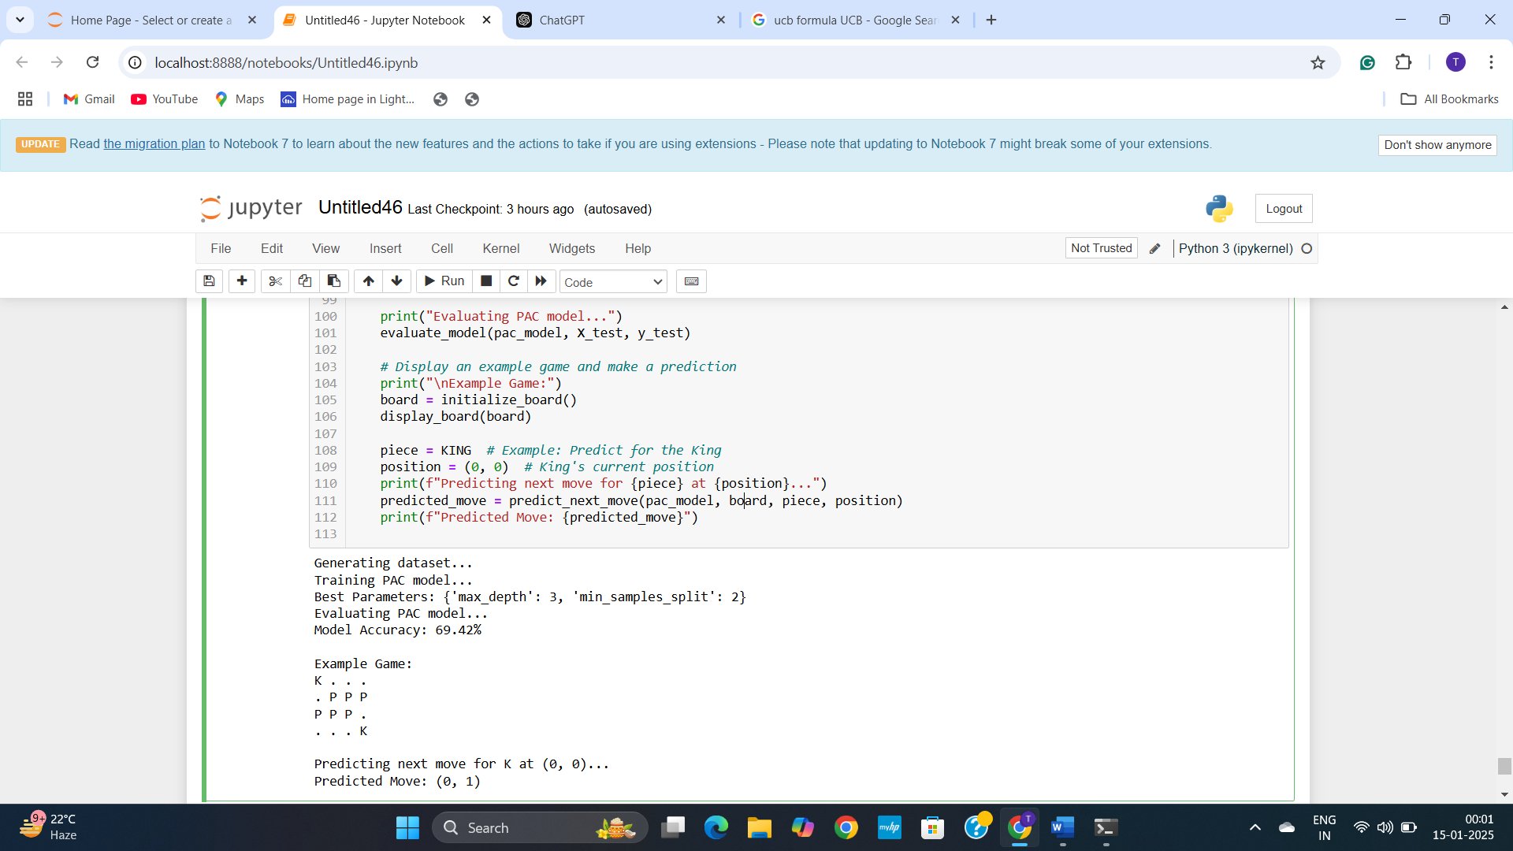

**Explanation:**

**Simplified Chess Game with PAC Learning**

**Overview**

This project implements a simplified chess-like game on a 4x4 board using PAC learning principles. The objective is to train a decision tree classifier to predict valid moves for pieces (King and Pawns) based on board states and positions.

**Problem Setup**

* **Game Environment**: The chessboard is simplified to a 4x4 grid. The pieces involved are the King (K) and Pawns (P), each with specific movement rules:
  + The **King** can move one step in any direction—diagonally, horizontally, or vertically.
  + **Pawns** move one step forward (towards the opposite end of the board). Empty cells are represented by a dot (.).
* **PAC Learning**: The model learns to approximate a move policy that predicts valid moves for a given piece. It uses supervised learning, where the dataset contains board states (features) and corresponding valid moves (labels).

**Implementation Details**

The project includes several key components:

* **Constants and Definitions**: The grid size is defined as BOARD_SIZE (4x4). Pieces are represented by constants: KING, PAWN, and EMPTY for an empty cell.
* **Board Initialization**: The initialize_board() function sets up the board with the King and Pawns in predefined positions.
* **Move Validation**: The get_valid_moves() function calculates all valid moves for a specified piece from a given position, considering the piece's movement rules and the board's boundaries.
* **Feature Extraction**: The board_to_features() function converts a board state into a feature vector. This includes encoding the King as 1, Pawns as 0.5, and empty cells as 0, along with normalized positional information for the piece.
* **Dataset Generation**: The generate_dataset() function generates a dataset of board states and corresponding valid moves. The board is randomly initialized, a piece is selected, and its valid moves are computed. A valid move is then chosen randomly, and the board state is converted into features, with the target being the selected move.
* **PAC Model Training**: The train_pac_model() function trains a Decision Tree Classifier using GridSearchCV to optimize hyperparameters such as max_depth and min_samples_split. This function returns the best-performing model.
* **Model Evaluation**: The evaluate_model() function evaluates the trained model using a test set, calculating and displaying the accuracy of the model’s predictions.
* **Gameplay Prediction**: A placeholder function (predict_next_move()) can be used to predict the next move for a given piece based on the trained model and board state.

**Usage**

To run the program, simply execute the script. The program will generate a dataset of board states and corresponding moves, train a PAC model, and evaluate its accuracy. It will then display an example game and make a move prediction for a selected piece.

The script provides key functionalities like displaying the board, generating a dataset, training the model, evaluating its performance, and predicting the next move.

**Example Output**

The program generates outputs as follows:

* **Dataset Generation**: The script will print a message indicating that the dataset has been generated.
* **Model Training**: During training, the script will output the best hyperparameters found for the Decision Tree model.
* **Model Evaluation**: After training, the script will display the accuracy of the model on the test data.
* **Gameplay Prediction**: The example game will be displayed, and the model will predict the next move for the King (or any other piece).

**Future Improvements**

There are several directions to enhance the project:

* **Heuristic-Based Move Selection**: The dataset generation could be improved by using optimal moves rather than selecting valid moves randomly.
* **Graphical User Interface (GUI)**: A visual interface could be added to make the game interactive and more user-friendly.
* **Error Bounds**: The implementation could be extended to compute PAC-related metrics, such as confidence intervals, to assess the model's performance within an error bound.

**Dependencies**

The script requires the following Python packages:

* Python 3.x
* NumPy
* scikit-learn

**Conclusion**

This project demonstrates how PAC learning can be applied to a simplified chess game. The decision tree classifier trained using supervised learning effectively predicts moves based on board states. The model shows promising results, and the system can be extended to include additional features like optimal move selection and graphical interfaces.